Chapter 2, Solution 63

Use eq. (2.61),

R_{n} = 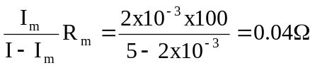
I_{n} = I - I_{m} = 4.998 A
p = 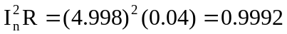 1 W

